Mrs. Ignotis’ Science Introduction Letter

E-mail: Tatiana\_ignotis@sarasota.k12.fl.us

Website: iggyenvironment.weebly.com

Welcome Student,

Welcome to 6th grade science and what I’m sure will be an exciting and successful school year! I am glad to have the opportunity to be your teacher this year.

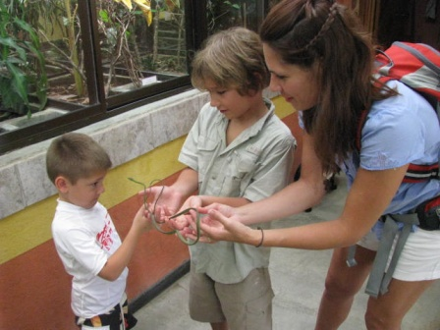

**About me:** First, I’ll tell you a bit about me; your teacher. This is my 12th year of teaching middle school. In addition to teaching, I also volunteer at horse rescue facility, with youth sports, and at church. I enjoy outdoor adventure, and traveling. I am married and have two sons. I have a Bachelors of Science, a Masters in Education, and a Florida Gifted Certification.

**About this science course**: This year we’ll be focusing on Earth and Space Science. Everything is **online** these days. You can check out the curriculum calendar for this year by visiting <http://www.floridastandards.org/homepage/index.aspx>. Your digital textbook app can be downloaded for free at [www.sarasotacountyschools.net/etexts](http://www.sarasotacountyschools.net/etexts) (hard copy texts are also available still). You can check out exactly what we’re up to at my website: [www.iggyenvironment.weebly.com](http://www.iggyenvironment.weebly.com) . You can even check on your grades online using the county’s online Crosspoint gradebook.

**My expectations for students**: I expect my students to work well with others and to try their best. If anyone is having trouble in my class, I encourage them to come to me and talk about it during an appropriate time. I am here to help. I do have four basic rules in my classroom. I will follow these rules as well. 1. Respect others. 2. Be safe. 3. Come to class prepared. 4. Stay on task. *As* the facilitator, I will need to redirect behavior jeopardizing the work environment. I will be implementing the VMS *school wide intervention system* in my classroom. I will also have a fun reward system in place (to be determined by my students).

**Contact Information**: I will do my best to assist my students and serve parents. I am available via e-mail or by phone here at school from 7:00-2:30 or by special appointment. We’re a team. Let’s work together to make this the best year yet!

I look forward to getting to know you this year,

Mrs. Ignotis

C:\Program Files\Microsoft Office\MEDIA\OFFICE14\Lines\BD21332_.gif

C:\Program Files\Microsoft Office\MEDIA\CAGCAT10\j0157995.wmf

**Supply List**

**Mrs. Ignotis’ Science, VMS**

**Science Materials:**

* **Plastic pocket folder (or one Section in a “trapper-keeper”-type binder or 3-ring binder)**
* **Composition notebook**

Keep in your backpack for your personal use in all classes:

* 1 additional pocket folder (for homework only)
* **Loose leaf paper**
* Zipper pouch to hold:
  + 1 Flash Thumb-Drive
  + **Pencils** with erasers
  + 1 box Colored pencils and/or skinny markers
  + 2 **Glue Sticks!!!**
  + *Recommmended: Hand held pencil sharpener* *(my sharpener will EAT your pencil, FYI)*

Collected for class use:

* 1 box of tissues or hand sanitizer
* 1 Ream Colored Printer Paper
* 1 box 4 Expo markers
* 2 Glue Sticks

*No white-out please.*

*Also, materials relating to our labs or current areas of study are greatly appreciated throughout the year. I may send home requests for small items for labs throughout the year. If you can help, we’d be very thankful. I understand that many feel a financial or time burden. With that said, I can assure you that all materials go directly to hands-on labs otherwise unavailable to the students without help from parents. Most of my students say their favorite part of science (and what they remember most) is the hands-on activities that we do (and field trips).*

*If you have questions or need help getting supplies, please feel free to contact me or the school. I feel positive that we’ll all be able to work together to make this a successful school year!*